

**Lawyers’ Mutual Member Benefits and**

**LMIC+ Account Set Up**

Screenshot 1: From the Lawyers’ Mutual homepage, click on the Member Login button.



Screenshot 2:

After selecting the ‘Member Login’ button from the main menu, you will be redirected to the Member Access page.

The Member Access landing page offers you with three options.

* **Lawyers’ Mutual Member Login.**
* **New Member request. \***
* Forgotten password link.

Screenshot 2a:

If you are able to login with existing credentials, please proceed to **page 6** for the next steps.

If you do not recall your password, please select “Forgot Password?”

Refer to screenshot 2b.

Screenshot 2b:

An email to reset your password will be sent to your email address.

Be sure to check your Spam or Junk folder.

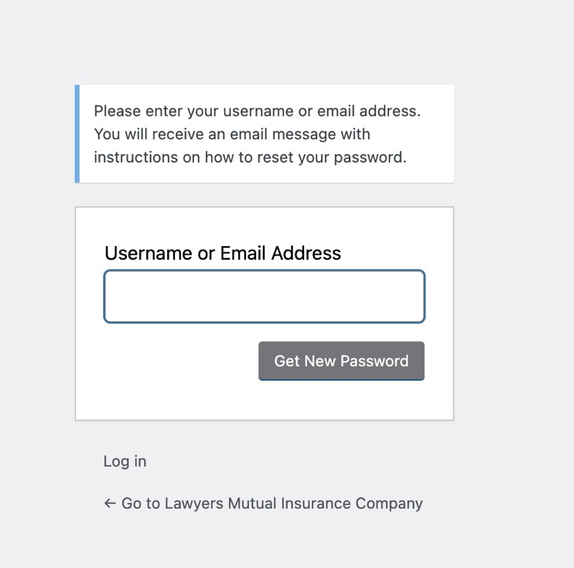

If you do not have an existing Member Benefits account with Lawyers’ Mutual, please proceed to fill out the [Member Benefits Registration Form.](https://www.lawyersmutual.com/lmic-account-registration-form/) *Refer to screenshot 2c below.*

Upon submitting your form, we will be in contact via email with the next steps to login.

Screenshot 2c:

Once complete, and you have logged in with your Lawyers’ Mutual Member Benefit account credentials, you will see the following screenshot 3.

Screenshot 3:

Click on “New Member? Register.” on the LMIC+ tile. You will need to create an account to access your CLE on LMIC+.

Screenshot 4:

After clicking on the “Register for LMIC+” button, input your Lawyers’ Mutual Member Benefit account credentials into the fields below.

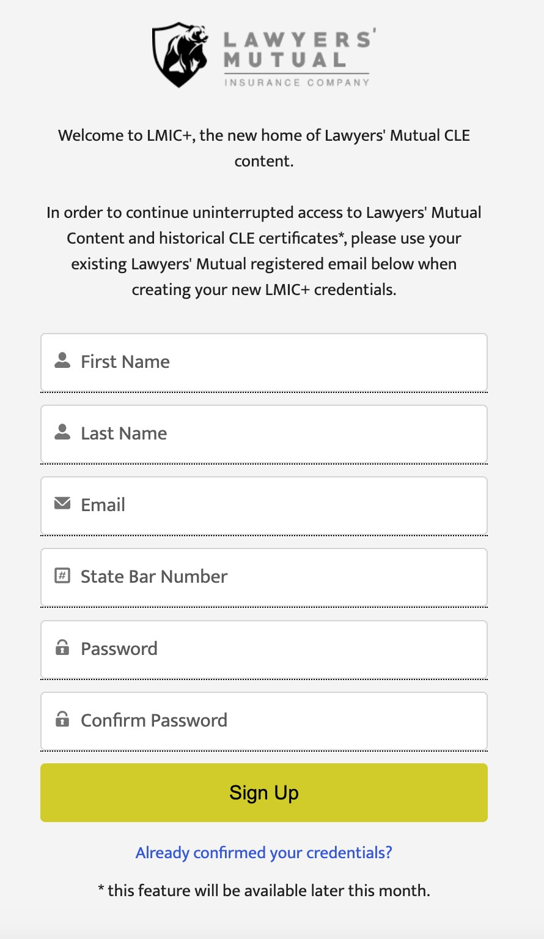

Screenshot 5:

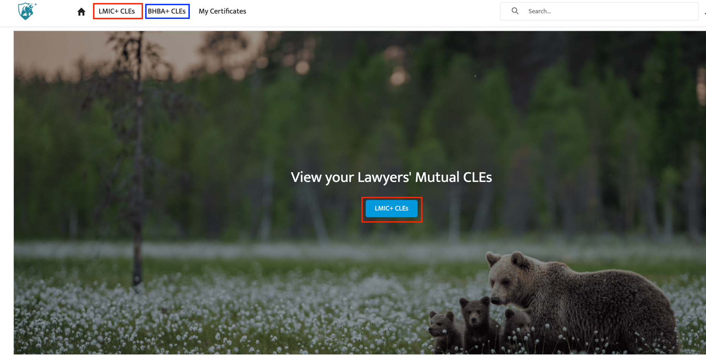After signing up for your LMIC+ account, you will be redirected to the following LMIC+ landing page. Click on either “LMIC+ CLEs” **(*outlined in red)*** or “LMIC+ CLEs” button ***(outlined in red)***to access your entire Lawyers’ Mutual catalogue.

Remember, you also gain free access to 25 hours of Beverly Hills Bar Association OnDemand (BHBA+) with your LMIC+ login. ***(outlined in blue)***

**LMIC+ FAQs**

Thank you to all our members for your due diligence during the transition to our enhanced free CLE platform, LMIC+.

Please refer to the following FAQs:

**I’m a new Lawyers’ Mutual member. How do I set up my Lawyers’ Mutual member benefit account?**

Email us at: MCLE@lawyersmutual.com with your first & last name along with your SBN to create your credentials.

**How do I reset my Lawyers’ Mutual member benefits account password?**

Reset your Lawyers’ Mutual login by sending an email to MCLE@lawyersmutual.com with your first name, last name, and CA State Bar Number or follow the links on the Member Benefits login page.

If you’re having issues loading our Member Benefits page, clear your cookies / cache from the last hour and refresh the webpage.

**Can I share my Lawyers’ Mutual member benefits login info with other attorneys at my firm?**

Every attorney listed on your policy should have their own Lawyers’ Mutual Member Benefits account before creating an LMIC+ account. If this isn’t the case, please email MCLE@lawyersmutual.com to assign them a personal username and password.

**What’s the difference between my Lawyers’ Mutual member benefits password and my LMIC+ password?**

Your Lawyers’ Mutual member benefits login grants you access to all your exclusive free member benefits. Your LMIC+ login gives you unlimited access to the new portal to your free Lawyers’ Mutual CLE content.

**Can I also access BHBA OnDemand CLEs?**

Yes, all Lawyers’ Mutual members have access to 25 free hours of BHBA produced OnDemand content. The good news is using your LMIC+ credentials, you can access the additional CLE content here: [BHBA.org/login](http://bhba.org/login), and is also available in LMIC+ in your main menu[.](http://bhba.org/login)

**How do I receive my CLE certificates?**

When you finish completing a seminar on LMIC+, your certificate is automatically emailed to you within minutes and is also stored in your LMIC+ profile for easy access.

**I think I’ve completed my CLE seminar, where’s my certificate?**

The State Bar rules are that CLE participatory seminars must be watched in their entirety; therefore you must watch the entire CLE to completion to receive your certificate

**My compliance group is not accurate. How do I correct this?**

If you need to change the compliance group listed on your LMIC+ profile, please reach out to CLEhelp.LawyersMutual@BHBA.org

**Who do I contact with other questions regarding LMIC+ Account Setup?**

For LMIC+ account set up support, please email CLEhelp.LawyersMutual@BHBA.org

Shielding your practice is our priority. For additional questions, please reach out to us at [mbinfo@lawyersmutual.com](mailto:mbinfo@lawyersmutual.com).

*\*You must have an active in-force policy to gain access to Lawyers’ Mutual member benefits.*